
ITA1403 - ETHICAL HACKING

LAB EXPERIMENTS 11 – 25

192321047
KAUSHIK NARAYANAN V

11. Execute and display the results for the following Nmap Timing and performance
commands in Kali Linux operating Systems:
(i) aggressive speed scan
(ii) insane speed scan

Aim
To execute and study Nmap aggressive and insane timing scans in Kali Linux.

Procedure
- Open the Kali Linux Terminal.
- Execute the commands on your own system or an authorized lab target.
- Observe and record the output.

Commands
i) Aggressive speed scan (T4)
nmap -T4 127.0.0.1
Output: Performs scanning at a faster speed.
ii) Insane speed scan (T5)
nmap -T5 127.0.0.1
Output: Performs scanning at a very high speed; results may be less reliable on slow or congested networks.

Result
Thus, Nmap aggressive (-T4) and insane (-T5) timing scans were executed in Kali Linux.
Note : 127.0.0.1 refers to your own Kali system. -T4 and -T5 are timing options, not guarantees of stealth or IDS evasion.
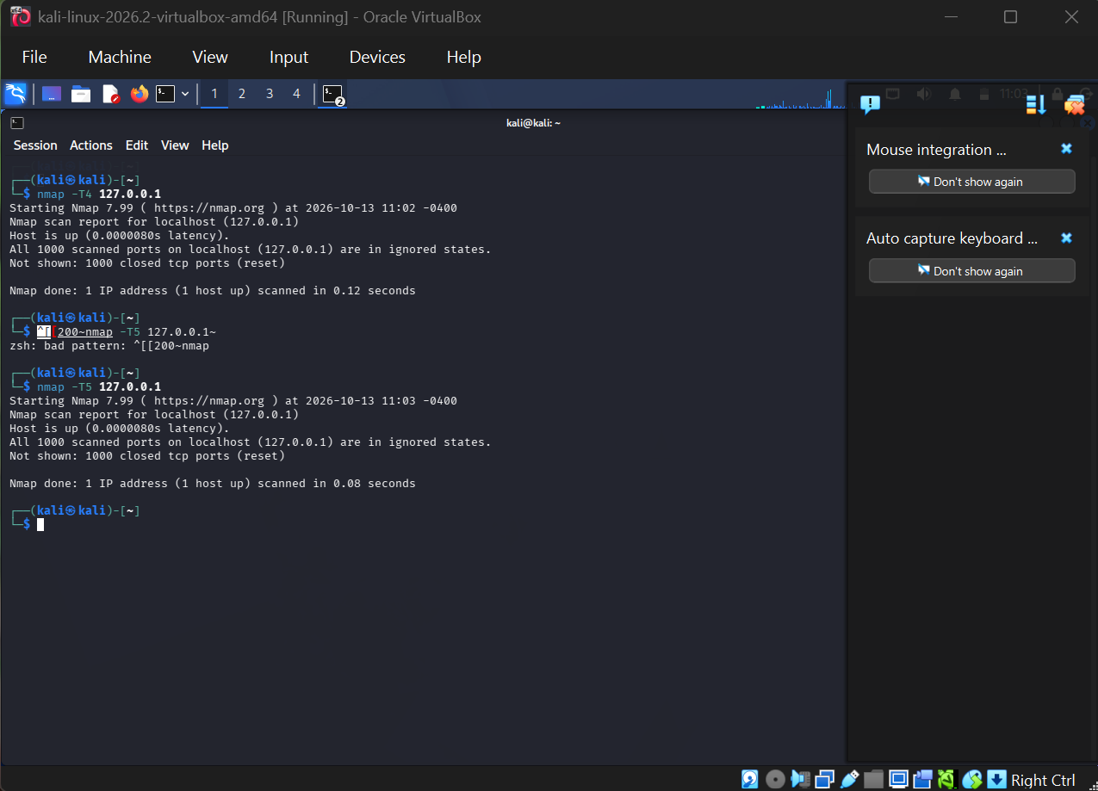
12. Port Scanning Tools

Aim
To perform port scanning using Nmap in Kali Linux.

Procedure
- Open the Kali Linux Terminal.
- Execute the following commands on your own system.
- Observe and record the results.

Commands
i) Scan common TCP ports
nmap 127.0.0.1
ii) Scan a specific port
nmap -p 5555 127.0.0.1
iii) Detect service versions
nmap -sV 127.0.0.1

Sample Output
PORT STATE SERVICE
5555/tcp closed freeciv
Note: Output depends on which ports are open on your Kali system. 127.0.0.1 refers to your own computer.

Result
Thus, port scanning was successfully performed using Nmap in Kali Linux.
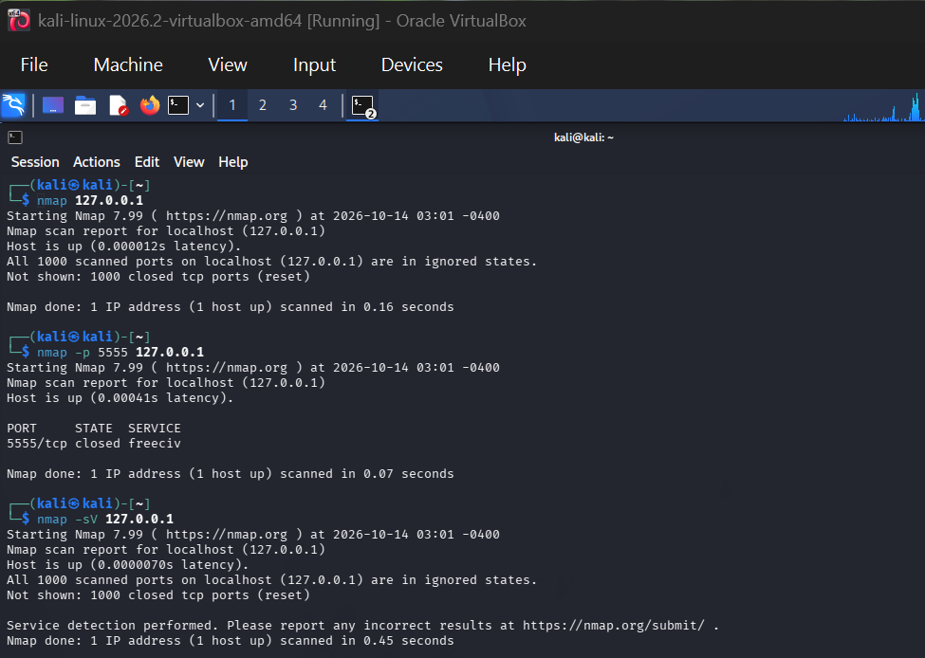

13. Host Discovery
Aim
To discover active hosts in an authorized local network using Nmap.
Procedure
1. Open the Kali Linux terminal.
2. Identify the IP address and subnet of your own lab network.
3. Scan only the private lab subnet that you own or have permission to test.
Commands / Program
Display local IP and route
ip addr
ip route
Host discovery scan (replace the example subnet with your lab subnet)
nmap -sn 192.168.1.0/24
Sample Output
Starting Nmap...
Nmap scan report for 192.168.1.1
Host is up (latency varies).
Nmap done: scanned hosts reported according to the lab network.
Note
Do not scan networks you do not own or have explicit permission to assess. The subnet and results will differ in your lab.
Result
Thus, host discovery was performed using Nmap on an authorized lab network.

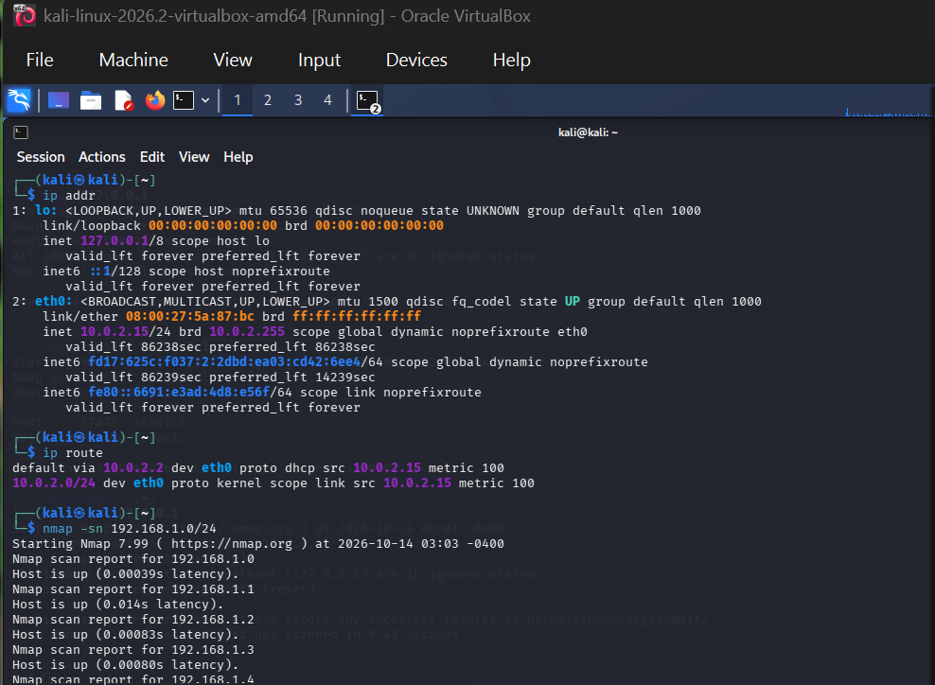14. Cracking a Test Password Using Hydra (Controlled Lab)
Aim
To understand how Hydra tests login credentials in a deliberately configured, authorized lab.
Procedure
1. Use only a test account on a machine you own or a dedicated training VM.
2. Ensure the test service is enabled and reachable; do not use real accounts or public systems.
3. Create a small test wordlist containing only passwords you created for this exercise.
Commands / Program
Create a tiny test wordlist
printf 'wrongpass\ntestpass123\n' > test-passwords.txt
Example command for an SSH service on your own lab machine
hydra -l labuser -P test-passwords.txt ssh://127.0.0.1
Sample Output
Hydra reports attempts against the configured test service. If the service is not running, the connection fails; if the credentials do not match, no valid password is reported.
Note
Run only against localhost or a lab VM you control, with explicit authorization. Do not use leaked lists, target other users, or attempt access to third-party systems.
Result
Thus, Hydra's password-testing process was studied in a controlled lab environment.
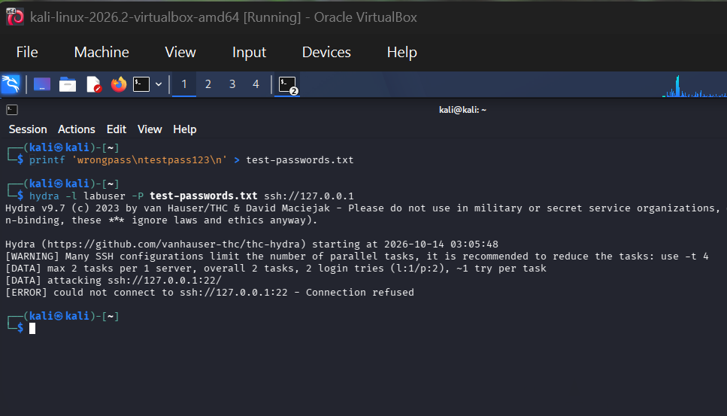
15. Information Gathering Using theHarvester
Aim
To collect publicly indexed email addresses, hostnames, and domain-related information for a permitted domain.
Procedure
1. Open the Kali Linux terminal.
2. Choose a domain you own or a domain explicitly approved for coursework.
3. Run theHarvester using a public search source and review the results.
Commands / Program
Example using a placeholder domain; replace with an authorized domain
theHarvester -d example.com -b duckduckgo
Sample Output
Output may list discovered hostnames, email addresses, and source information. Results depend on the domain and data source.
Note
Use the results responsibly and follow the search provider's terms and applicable privacy rules.
Result
Thus, passive information gathering was demonstrated using theHarvester.
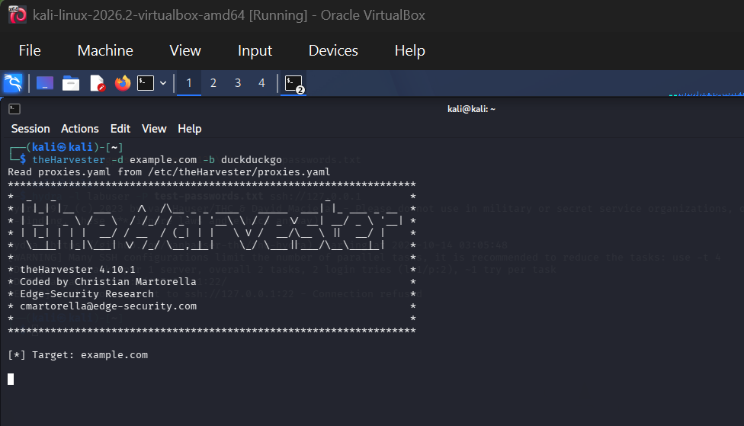16. Use Google and WHOIS for Reconnaissance
Aim
To understand basic open-source reconnaissance using search engines and WHOIS domain registration data.
Procedure
1. Open a browser and search for publicly available information about an approved domain.
2. Open a WHOIS lookup service or use the Kali terminal.
3. Record only information relevant to the lab and avoid collecting personal information unnecessarily.
Commands / Program
Google search examples (enter in browser)
"site:example.com"\n"site:example.com filetype:pdf
WHOIS lookup in Kali
whois example.com
Sample Output
Google may show indexed pages and documents. WHOIS may show registrar, domain dates, name servers, and—where not privacy-protected—registration details.
Note
Use a domain you own or are authorized to assess. Replace example.com with the approved domain.
Result
Thus, Google and WHOIS were used to demonstrate passive reconnaissance. 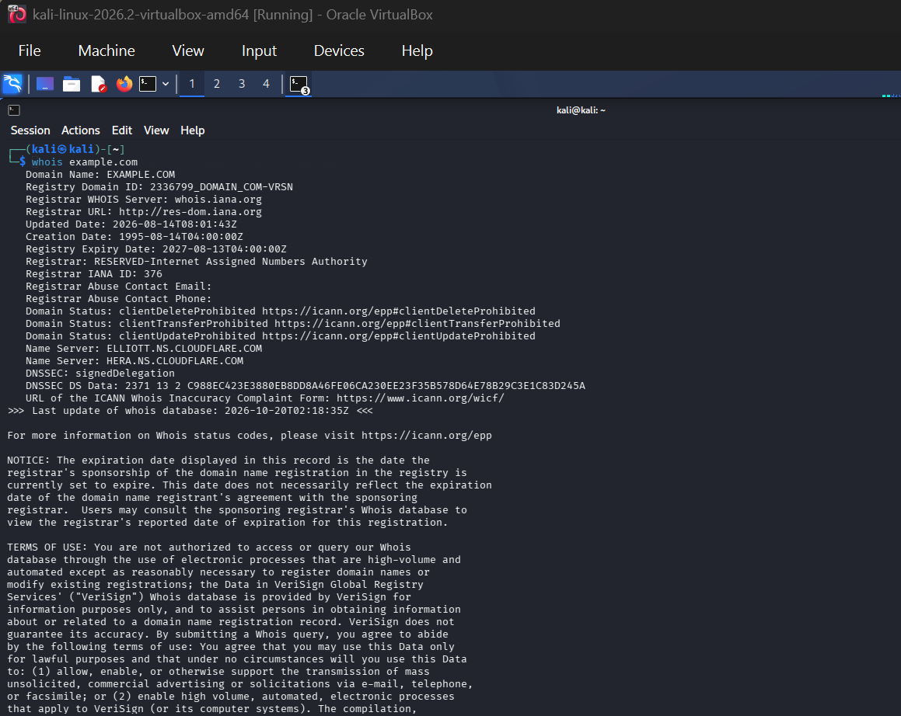

17. Windows OS Commands Execution: traceroute, ping, ifconfig, netstat
Aim
To execute equivalent network diagnostic commands on Windows and understand their purpose.
Procedure
1. Open Command Prompt (CMD) on Windows.
2. Run each command and observe the output.
3. Note: ifconfig is a Unix/Linux command; Windows uses ipconfig for similar interface information.
Commands / Program
Check connectivity
ping 127.0.0.1
Trace the route
tracert 127.0.0.1
Display network configuration (Windows equivalent of ifconfig)
ipconfig /all
Display network connections and listening ports
netstat -ano
Sample Output
ping shows replies or packet-loss statistics; tracert lists route hops; ipconfig /all displays adapter configuration; netstat -ano displays connections, listening ports, and process IDs.
Note
On Linux, use traceroute (or tracepath), ping, ifconfig/ip addr, and netstat/ss as available.
Result
Thus, network diagnostic commands and their Windows equivalents were executed. 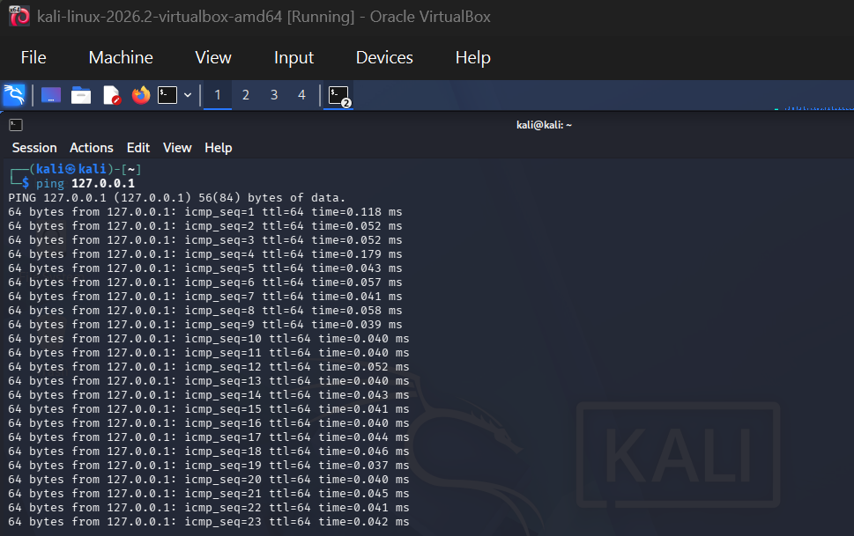

18. Vulnerability Analysis Using CGI Scanning with Nikto
Aim
To learn how Nikto checks a web server for common configuration issues and potentially risky files.
Procedure
1. Start a web server in your own lab VM, or use a deliberately vulnerable training target.
2. Confirm that you have permission to scan the selected host.
3. Run Nikto against the local test server and review its findings.
Commands / Program
Scan a local web server
nikto -h http://127.0.0.1
Sample Output
Output may report server headers, missing security headers, outdated components, or potentially exposed paths. Findings require manual verification and may include false positives.
Note
Only scan localhost or explicitly authorized targets. Do not treat a scan result alone as proof of exploitability.
Result
Thus, Nikto was used to inspect a locally hosted web server for common web-server issues. 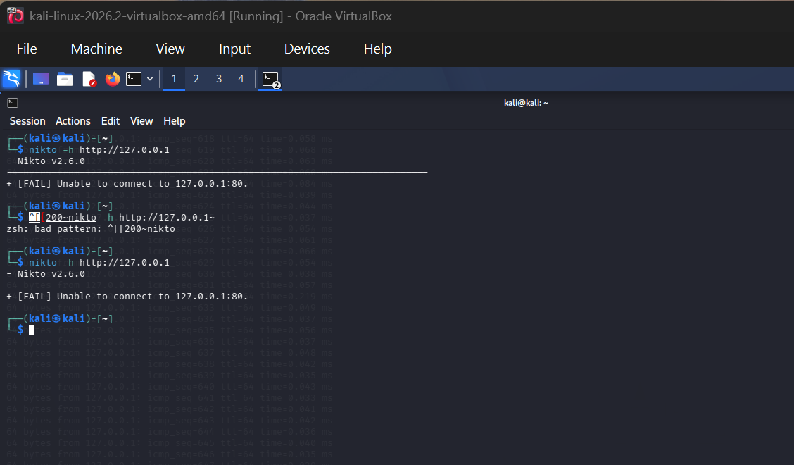
19. Wireshark Sniffer for Network Traffic and Analysis
Aim
To capture and inspect network packets generated by the user's own computer in Wireshark.
Procedure
1. Open Wireshark and select the loopback or active network interface.
2. Start capture.
3. Generate simple traffic by opening a website you are authorized to access or by pinging localhost.
4. Stop capture and inspect packet details.
Commands / Program
Generate sample traffic in a terminal
ping -c 4 127.0.0.1
Useful Wireshark display filters
icmp
arp
dns
tcp
Sample Output
Wireshark displays captured packets with columns such as time, source, destination, protocol, length, and information. The available packets depend on the chosen interface and traffic.
Note
Capture only traffic you are authorized to inspect. Encrypted application content generally cannot be read as plain text.
Result
Thus, network traffic was captured and analyzed using Wireshark. 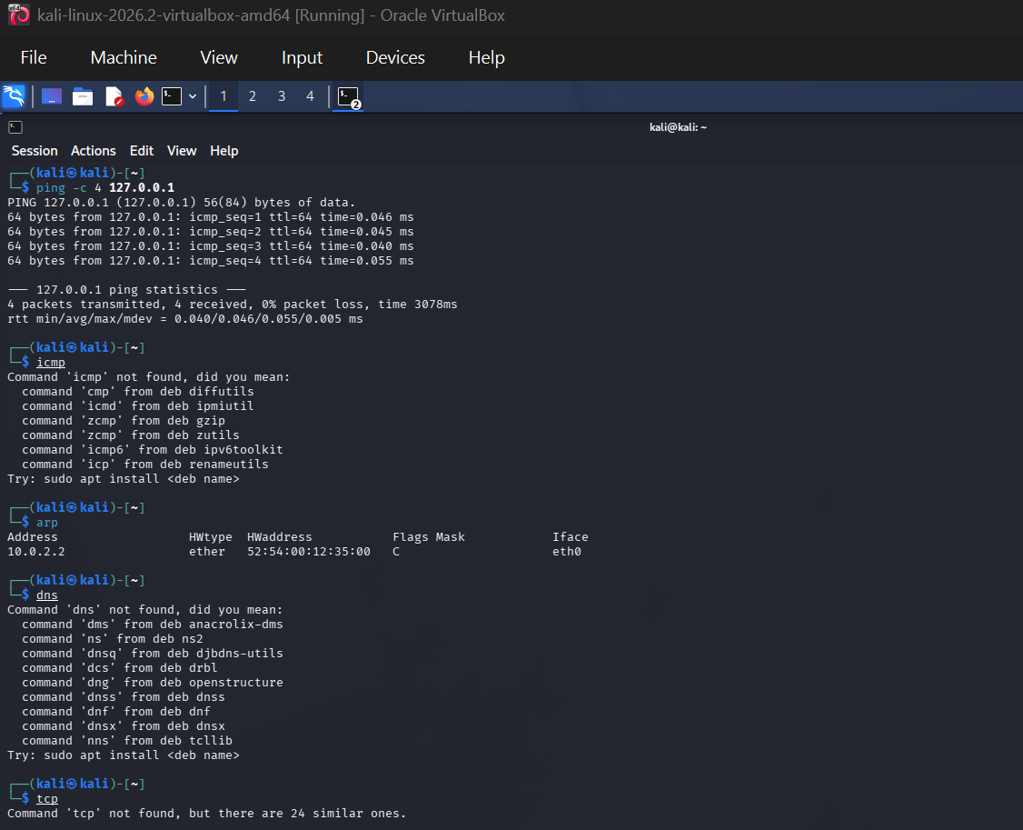

20. Understanding Msfvenom and Boot-Sector Malware Safety
Aim
To study the role of msfvenom in security testing and safely examine a harmless file artifact without creating or deploying a boot-sector virus.
Procedure
1. Open the Kali Linux terminal in an isolated lab.
2. Check whether msfvenom is installed and view its help information.
3. For this experiment, do not generate boot-sector code, a virus, persistence, or a payload intended to damage or compromise a system.
4. Create a harmless text artifact and verify its file type.
Commands / Program
View msfvenom help
msfvenom --help
Create and inspect a harmless artifact
printf 'Harmless lab artifact only.\n' > lab-artifact.txt
file lab-artifact.txt
cat lab-artifact.txt
Sample Output
msfvenom displays its available options. The file command identifies lab-artifact.txt as a text file, and cat displays the harmless message.
Note
An operational boot-sector virus or destructive boot payload is intentionally not included. Such code can render a system unbootable or destroy data; use instructor-provided, non-executing samples in an isolated analysis lab.
Result
Thus, msfvenom's purpose was reviewed and a harmless artifact was created for safe lab documentation. 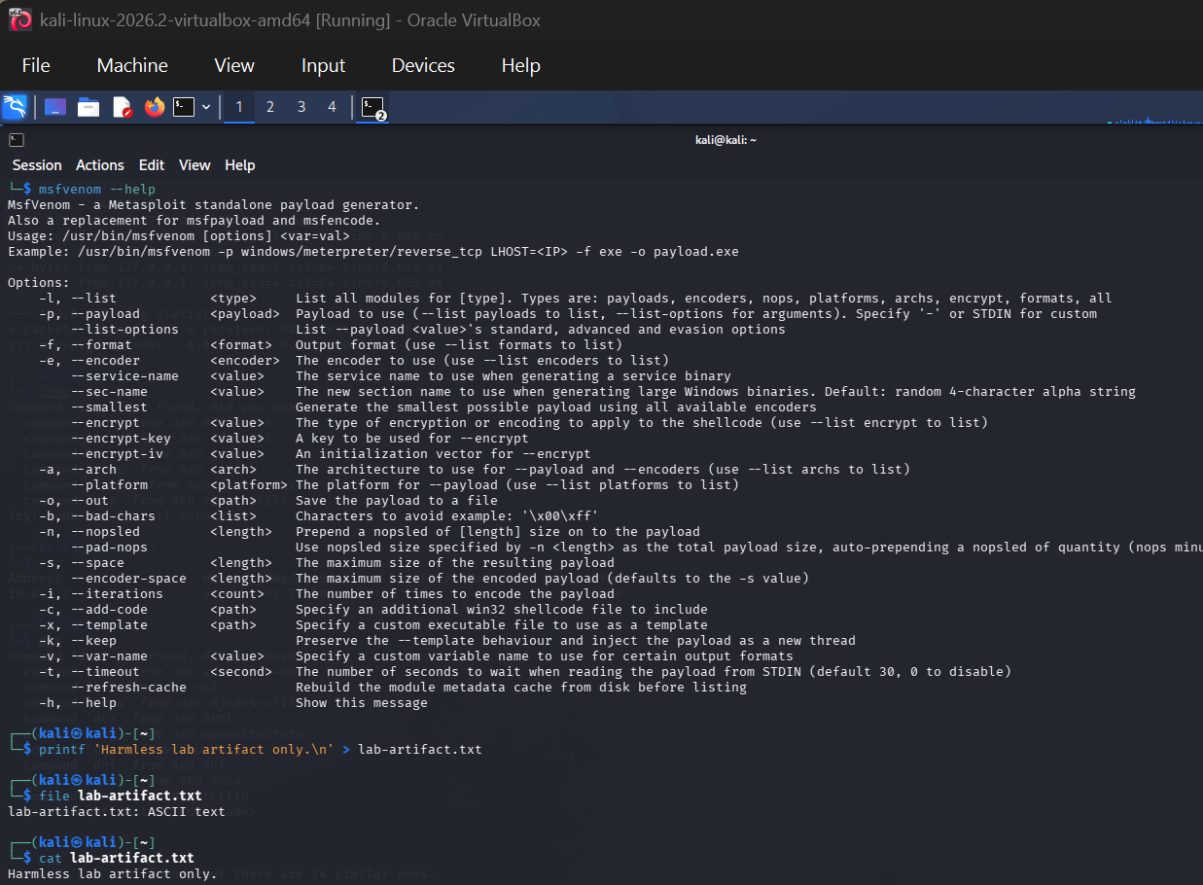
21. Batch File Execution
Aim
To create and execute a basic Windows batch file that displays messages and system information.
Procedure
1. Open Notepad.
2. Type the batch program shown below and save it as lab.bat (select All Files as the file type).
3. Open Command Prompt, navigate to the save location, and execute the file.
Commands / Program
Contents of lab.bat
@echo off
echo Batch file execution demonstration
echo Current date and time:
date /t
time /t
echo Current directory:
cd
pause
Execute from CMD
lab.bat
Sample Output
The batch file prints a message, displays date/time and the current directory, then waits for a key press.
Result
Thus, a Windows batch file was created and executed successfully.
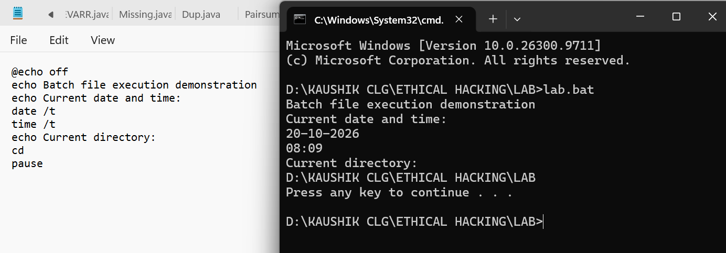

22. Packet Analyser Tool
Aim
To inspect packet headers and protocol details using a packet analysis tool such as TShark or Wireshark.
Procedure
1. Open the Kali Linux terminal.
2. List available capture interfaces.
3. Capture a small number of packets on an interface you control, or read a previously captured sample file.
4. Review protocol and endpoint summaries.
Commands / Program
List interfaces
tshark -D
Capture a small sample on loopback (interface name may vary)
sudo tshark -i lo -c 10
Read a saved capture file
tshark -r sample.pcapng
Sample Output
TShark lists packet numbers, timestamps, source/destination addresses, protocols, and packet details. The saved-file command works only when sample.pcapng exists.
Note
Choose the correct interface for your system and capture only authorized traffic.
Result
Thus, packet analysis was demonstrated using TShark, the command-line companion to Wireshark. 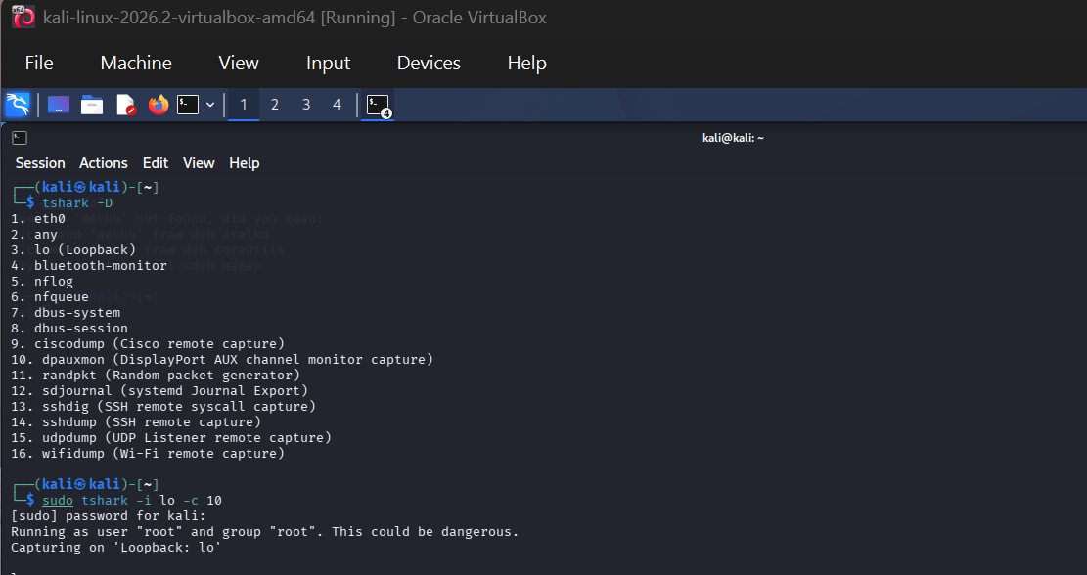
23. Port Scanning Tools (Extended)
Aim
To perform basic and extended port scanning against the local system using Nmap.
Procedure
1. Open the Kali Linux terminal.
2. Use localhost as the target for the demonstration.
3. Run the scans and compare the reported port states and service information.
Commands / Program
Scan common ports
nmap 127.0.0.1
Scan selected ports
nmap -p 22,80,443 127.0.0.1
Scan all TCP ports on localhost
nmap -p- 127.0.0.1
Detect service versions on localhost
nmap -sV 127.0.0.1
Sample Output
Sample format:
PORT STATE SERVICE
22/tcp closed ssh
80/tcp closed http
Actual port states depend on services running on the local system.
Note
Scan only systems you own or have permission to test. Actual output may differ.
Result
Thus, basic, selected-port, full TCP-port, and service-version scans were demonstrated on localhost. 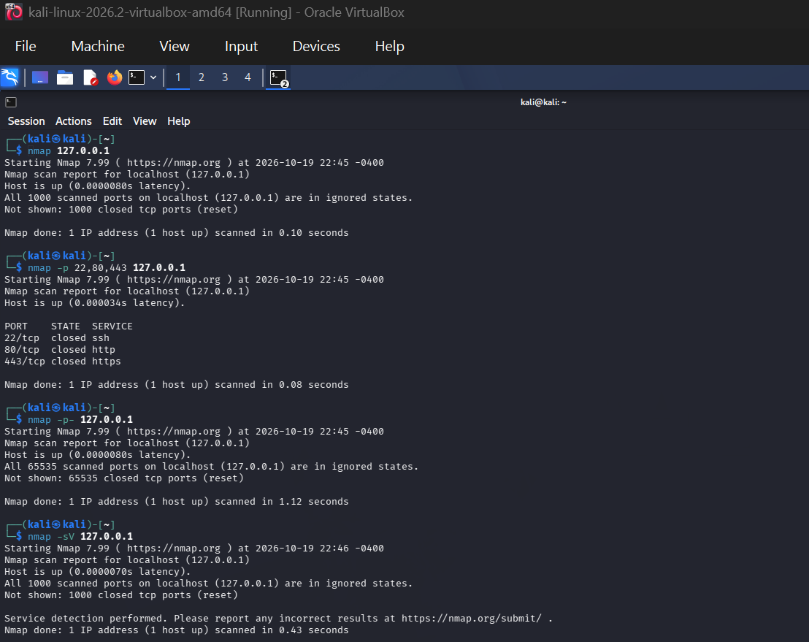

24. Nmap Timing and Performance
Aim
To compare Nmap timing templates and observe their effect on scan speed and network load.
Procedure
1. Open the Kali Linux terminal.
2. Run the timing templates against localhost.
3. Compare completion time and output; do not interpret timing templates as guaranteed stealth or IDS evasion.
Commands / Program
Polite timing
nmap -T2 127.0.0.1
Normal timing
nmap -T3 127.0.0.1
Aggressive timing
nmap -T4 127.0.0.1
Insane timing
nmap -T5 127.0.0.1
Sample Output
Each command reports discovered ports and scan completion information. Timing differences may be small on localhost.
Note
T4 and T5 can increase network load and may reduce reliability on slow or congested networks. Use only in an authorized environment.
Result
Thus, Nmap timing templates T2, T3, T4, and T5 were compared in a controlled lab. 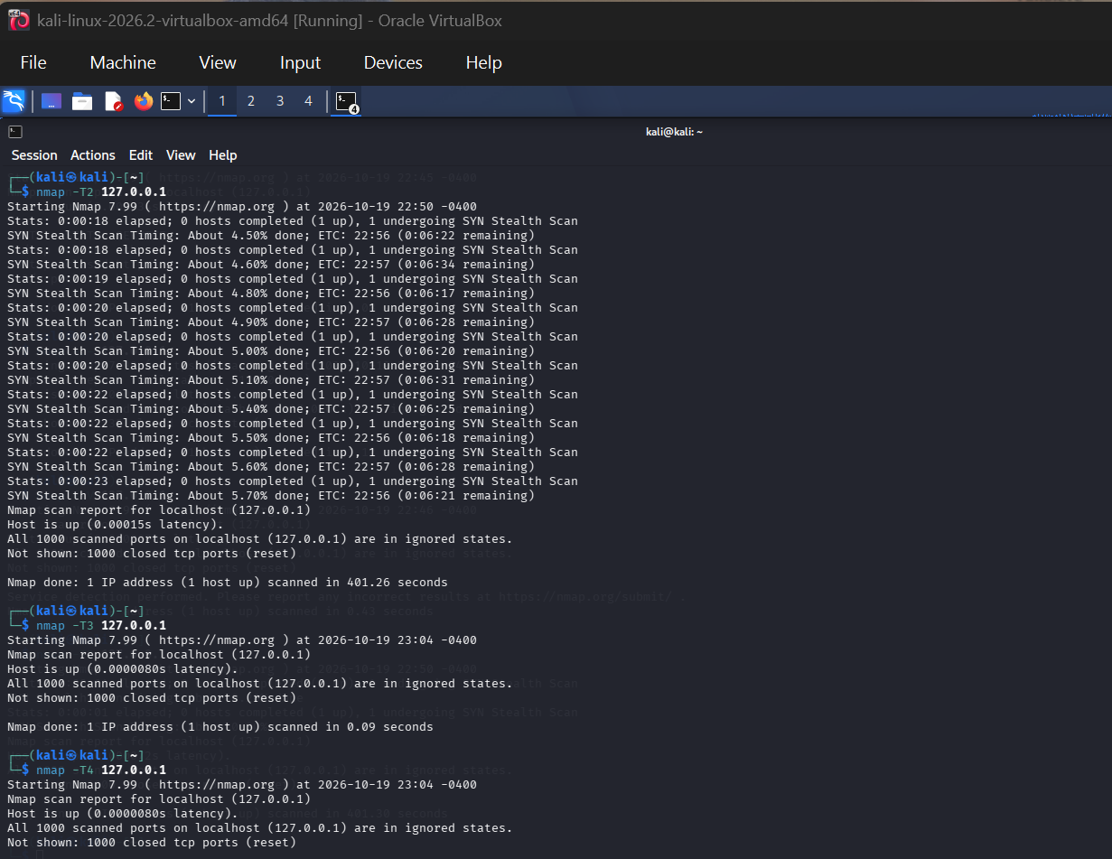
25. Shell Programming: Square of a Number and Biggest of Three Numbers
Aim
To write and execute shell scripts that calculate the square of a number and find the largest of three numbers.
Procedure
1. Open the Kali Linux terminal.
2. Create each script using a text editor or a heredoc.
3. Make the script executable and run it with sample inputs.
Commands / Program
i) Square of a number — save as square.sh
#!/bin/bash
read -p 'Enter a number: ' n
square=$((n * n))
echo "Square = $square"
Run the first script
chmod +x square.sh
./square.sh
ii) Biggest of three numbers — save as biggest.sh
#!/bin/bash
read -p 'Enter first number: ' a
read -p 'Enter second number: ' b
read -p 'Enter third number: ' c
if [ "$a" -ge "$b" ] && [ "$a" -ge "$c" ]; then
biggest=$a
elif [ "$b" -ge "$a" ] && [ "$b" -ge "$c" ]; then
biggest=$b
else
biggest=$c
fi
echo "Biggest number = $biggest"
Run the second script
chmod +x biggest.sh
./biggest.sh
Sample Output
Example 1:
Enter a number: 6
Square = 36
Example 2:
Enter first number: 12
Enter second number: 7
Enter third number: 19
Biggest number = 19
Note
These examples use integer arithmetic and integer comparisons in Bash.
Result
Thus, both shell programs were written and executed successfully.
